**RGB LED**

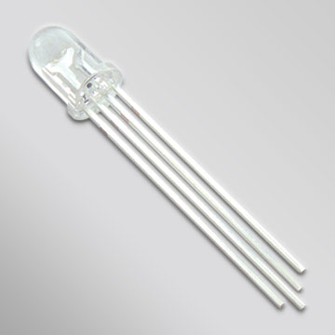

**What It Does:** This LED has three different colors, red, blue, and green. They can be turned on individually and at different brightness levels to create a variety of colors.

**Required Connections**: There are four pins on the LED, one for each color and one for ground. This component should already be wired for the workshop. Each wire should correspond to the appropriate color, and black should be connected to ground. *Note: It is possible for LEDs to burn out. We have extras if this happens.*  
  
Red: wire for the Red LED, connect this pin to one of the **PWM pins {5,6,9}**.  
Green: wire for the Green LED, connect this pin to one of the **PWM pins {5,6,9}**.  
Blue: wire for the Blue LED, connect this pin to one of the **PWM pins {5,6,9}**.

**Using the RGB LED in Scratch:**  
To turn on the individual LEDs, use the *analogWrite* block to adjust the voltage sent to each pin. In AnalogWrite you must select a pin and value to write. A value of 0 will send no voltage and the LED will be off. A value of 255 will send the maximum voltage and the sensor will be at its brightest. In the example below, the LED attached to pin 5 is set to its brightest.

E:\My Dropbox\PhD\IDSA Workshop\Images\AnalogWriteBlock.png

Figure 1: Turing on Pin 5 to Maximum Brightness

A variable can be used in place of a fixed number. In the example below, the variable Blue is initially set to zero, then incremented to 255. Each iteration of the loop stops for 1 second to show the brightness of the LED.

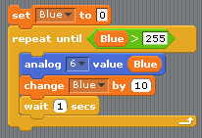

Figure 2: Looping Through All Brightness For An LED Attached to Pin 6